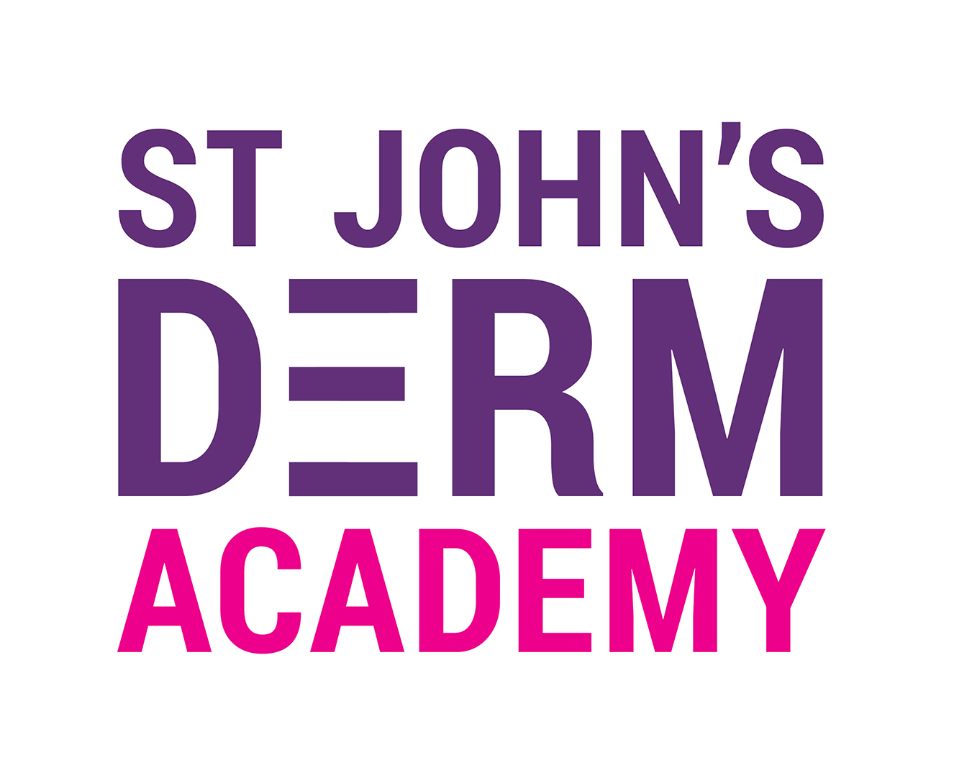
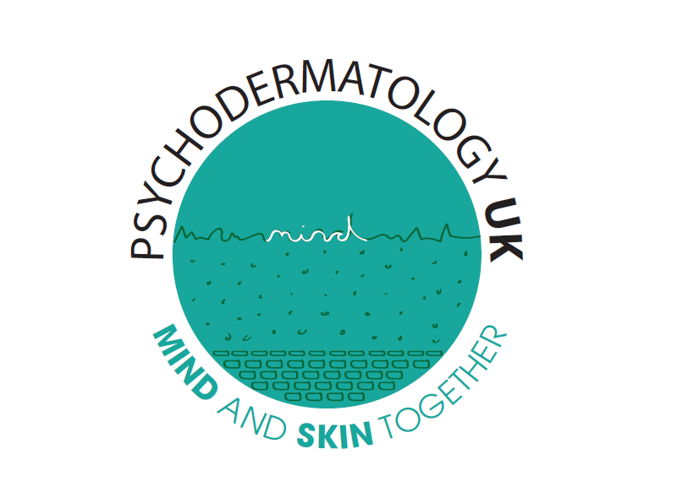

Abstract Application form / “Ask the Experts” Questions
Psychodermatology Live Webinar
Thursday 26th Jan 2023
Closing date 31st October 2022 5pm

Abstract instructions

The material to be presented must be original and not already published as a full paper. Please ensure that your abstract is 400 words or fewer or it will not be considered. If you are submitting a study then the body of the abstract should include a statement outlining the aim of the study, the methods used, a summary of the results and a conclusion. If submitting a case report, please highlight the learning points. An anonymous selection process will be used so please do not use identifying features in the title or text of the abstract.

Please email to: psychodermatology@hotmail.com

Presenting Author Name:

Presenting Author job title and work establishment:

Collaborating Authors names/ titles/ establishment:

Presenting author address:

Contact telephone number:

Presenting author contact e-mail address:

Title of Abstract: (Please ensure content of Abstract is 400 words or fewer)

Question for “Ask the Experts” Panel:

